**Ci/CD Pipeline with GitHub to create or Update Lambda Function**

* create a role for the lambda function.

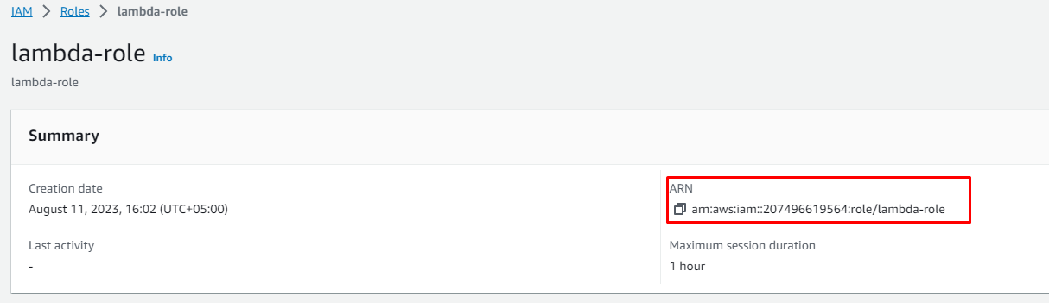

Then create a pipeline source with your github repo and connection desire branch should have following files mention below snapshot

**Then use the mentioned below code for build spec**

**version: 0.2**

**phases:**

**build:**

**commands:**

**- echo "Checking if Lambda function exists..."**

**- existing_function=$(aws lambda list-functions --query "Functions[?FunctionName=='MyLambdaFunction2'].FunctionName" --output text)**

**- >**

**if [ -z "$existing_function" ]; then**

**echo "Creating Lambda function..."**

**zip -r lambda_code.zip .**

**aws lambda create-function --function-name MyLambdaFunction2 --runtime python3.8 --role arn:aws:iam::207496619564:role/lambda-role --handler lambda_function.lambda_handler --zip-file fileb://lambda_code.zip**

**else**

**echo "Updating Lambda function..."**

**zip -r lambda_code.zip .**

**aws lambda update-function-code --function-name MyLambdaFunction2 --zip-file fileb://lambda_code.zip**

**fi**

**artifacts:**

**files: lambda_code.zip # Include the created zip archive in the build artifact**

**now above code changes the function name with the function which you want to create and the role arn with your role arn**

